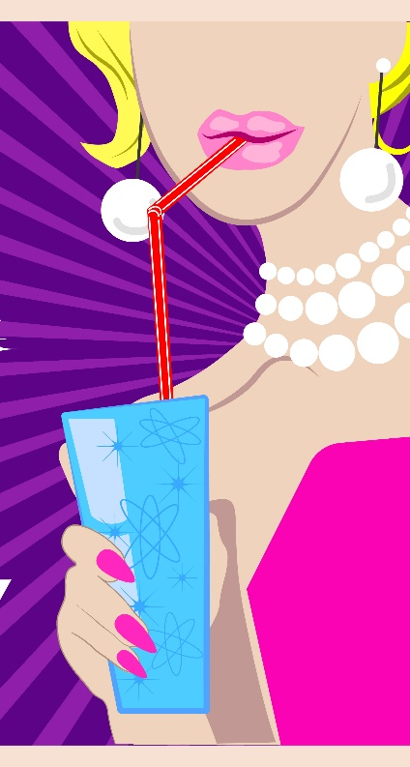
Hills Slushie Party Hire
www.hillsslushiepartyhire.com.au
Email: info@hillsslushiepartyhire.com.au
Phone Mandy: 0448 884 944

Recipes for Cocktails
Each recipe makes 10 litres of ready to drink Cocktail with an alcohol content of 5.5% alc/Vol.

Banana Daquiri  Bacardi 1400ml  Banana Daquiri Base 2000ml  Water 6600ml | Coyote Ugly  Tequila 1400ml  Coyote Ugly Base 2000ml  Water 6600ml
Blue Lagoon  Vodka 1400ml  Blue Lagoon Base 2000ml  Water 6600ml | Dillusion  Vodka 1400ml  Dillusion Base 000ml  Water 6600ml
Bourbon and Cola  Bourbon 1400ml  Coke Base 2000ml  Water 6600ml | Fruit Tingle  Vodka 1400ml  Fruit Tingle Base 2000ml  Water 6600ml
Caribbean Breeze  Bacardi 1400ml  Caribbean Breeze Base 2000ml  Water 6600ml | Gladiator  Vodka 1400ml  Red Gladiator Base 2000ml  Water 6600ml
Cosmopolitan  Vodka 1400ml  Cosmopolitan Base 2000ml  Water 6600ml | Head Rush  Vodka 1400ml  Head Rush Base 2000ml  Water 6600ml

Hills Slushie Party Hire
www.hillsslushiepartyhire.com.au
Email: info@hillsslushiepartyhire.com.au
Phone Mandy: 0448 884 944

Recipes for Cocktails
Each recipe makes 10 litres of ready to drink Cocktail with an alcohol content of 5.5% alc/Vol.
Jungle Juice  Vodka 1400ml  Jungle Juice Base 2000ml  Water 6600ml | Passionfruit Daiquiri  Bacardi 1400ml  Passionfruit Daiquiri Base 2000ml  Water 6600ml
Lemon Marguerita  Tequila 1400ml  Lemon Marguerita Base 2000ml  Water 6600ml | Peach Bellini  Vodka 1400ml  Champagne (3x750ml) 2250ml  Peach Bellini Base 2000ml  Water 5050ml
Mango Daquiri  Bacardi 1400ml  Mango Daquiri Base 2000ml  Water 6600ml | Pina Colada  Bacardi 1400ml  Pina Colada Base 2000ml  Water 6600ml
Melon Daiquiri  Bacardi 1400ml  Melon Daiquiri Base 2000ml  Water 6600ml | Purple Fruit Tingle  Vodka 1400ml  Purple Fruit Tingle Base 2000ml  Water 6600ml
Mojito  White Rum 1400ml  Mojito Base 2000ml  Water 6600ml | Red Sex On the Beach  Vodka 1400ml  Red Sex On the Beach 2000ml  Water 6600ml

Hills Slushie Party Hire
www.hillsslushiepartyhire.com.au
Email: info@hillsslushiepartyhire.com.au
Phone Mandy: 0448 884 944

Recipes for Cocktails
Each recipe base makes 10 litres of ready to drink Cocktail with an alcohol content of 5.5% alc/Vol.

Purple Sex On the Beach  Vodka 1400ml  Purple Sex On the Beach 2000ml  Water 6600ml | Tequila Sunrise  Tequila 1400ml  Tequila Sunrise Base 2000ml  Water 6600ml
Singapore Sling  Gin 1400ml  Singapore Sling Base 2000ml  Water 6600ml | Toby  Vodka 1400ml  Toby Base 2000ml  Water 6600ml
Strawberry Daiquiri  Bacardi 1400ml  Strawberry Daiquiri Base 2000ml  Water 6600ml | Tropical Storm  Dry White Wine 1400ml  Tropical Storm Base 2000ml  Water 6600ml

